|  |  |
| --- | --- |
| Date | 26 June 2025 |
| Team ID | LTVIP2025TMID51528 |
| Project Name | Strategic Product Placement Analysis:  Unveiling Sales Impact with Tableau Visualization |

**Final Report**

### 1.INTRODUCTION

### 1.1 Project Overview

### The Strategic Product Placement Analysis project aims to help retail businesses identify how product positioning across shelves, categories, and store locations affects sales performance. Using Tableau, we cleaned and visualized sales data from CSV files to generate actionable insights. The interactive dashboard includes KPIs, heatmaps, bar charts, and filters for dynamic exploration. A supporting story guides users through key findings and strategic decisions. This solution empowers retailers to optimize merchandising and boost revenue through data-driven insights.

### 1.2 Purpose

## The purpose of this project is to provide a visual, data-driven tool that enables retail teams to make informed, strategic decisions about product placement, ultimately improving sales efficiency and customer experience.

## 2. IDEATION PHASE

### 2.1 Problem Statement

### Retail analysts, marketing teams, and decision-makers at retail chains struggle to make confident, data-driven merchandising decisions due to the complexity and volume of sales and placement data. Despite having access to raw sales records, they face challenges in identifying which products perform best across store locations, shelf zones, and categories. Understanding how placement influences sales is difficult without visual context. These stakeholders lack an intuitive, centralized dashboard that highlights trends and actionable insights, resulting in missed opportunities, delayed strategies, and suboptimal product positioning.

### 2.2 Empathy Map Canvas

An empathy map is a simple, easy-to-digest visual that captures knowledge about a user’s behaviours and attitudes.

It is a useful tool to helps teams better understand their users.

Creating an effective solution requires understanding the true problem and the person who is experiencing it. The exercise of creating the map helps participants consider things from the user’s perspective along with his or her goals and challenges.

**Who is the user?**

The users of this project are retail marketing managers, brand strategists, visual merchandisers, and data analysts at consumer goods or retail companies. These professionals need clear, actionable insights from sales, product placement, and consumer behavior data to optimize product visibility and boost conversions. They value interactive Tableau dashboards that reveal how different product positioning strategies impact customer engagement and sales performance. This project helps them overcome challenges with fragmented data by providing visual, data-driven guidance to refine merchandising, enhance marketing effectiveness, and maximize revenue.

**Key user insights:**

The empathy map reveals several user insights. The user:

• Says things like “We need to know which product placements drive the most sales” and “Are customers actually noticing products placed at eye level or near checkout?” • Thinks about “Are we placing the right products in high-traffic zones?” and “What if we're missing out on sales due to poor visibility or layout?”

• Does actions like “Analyzes sales performance by shelf or web placement using Tableau dashboards” and “Compares product sales across different store zones or screen locations to identify effective positioning strategies.”

**Example for this project of Visualizing Strategic Product Placement Analysis:Prices and Features using Tableau**

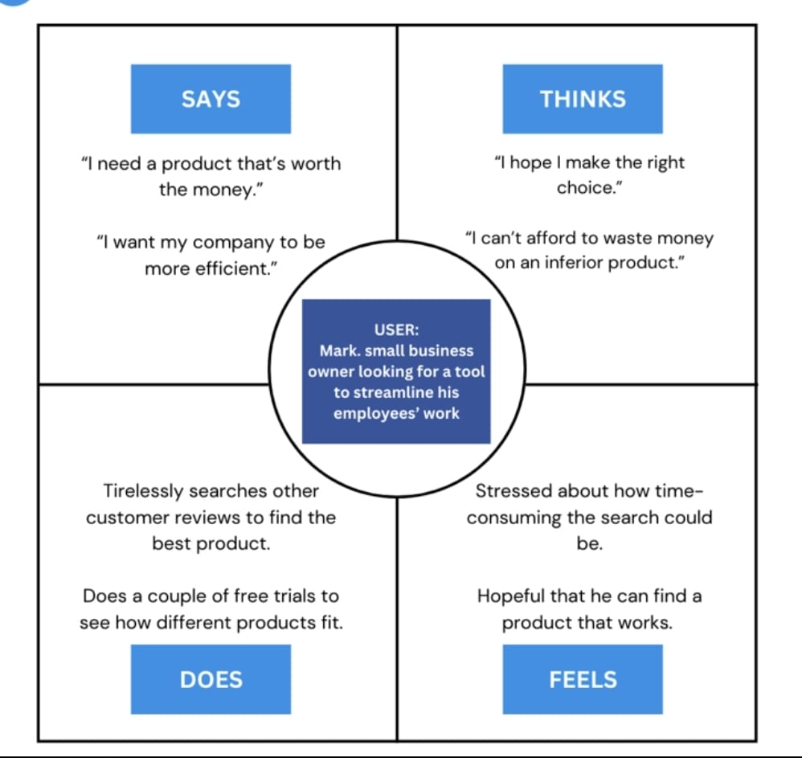

### 2.3 Brainstorming

**Brainstorm & Idea Prioritization:**

**Step-1: Team Gathering, Collaboration and Select the Problem Statement**

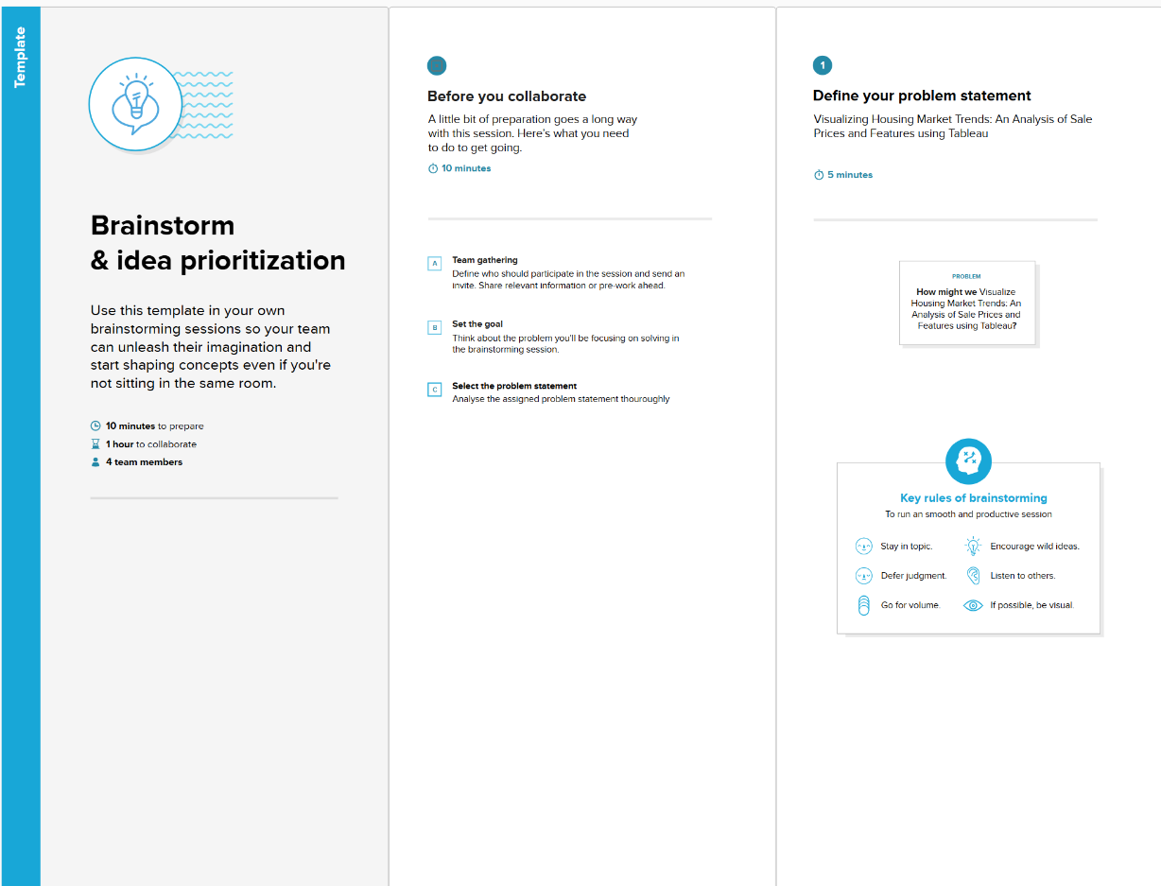

**Step-2: Brainstorm, Idea Listing and Grouping**

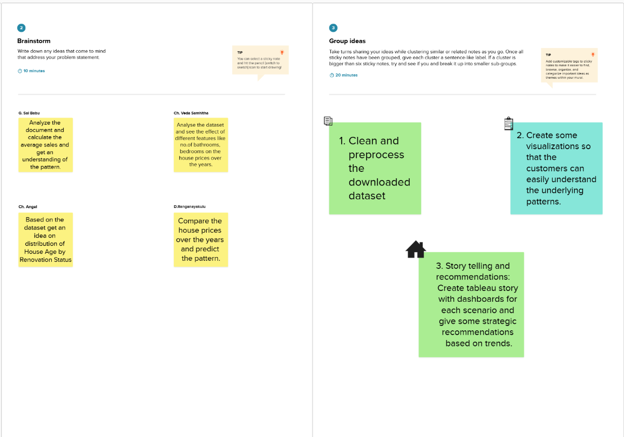

**Step-3: Idea Prioritization**

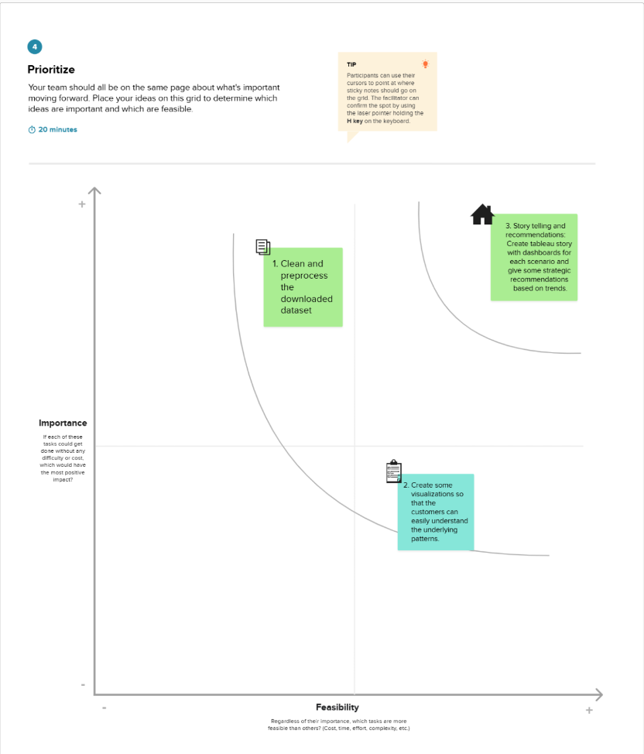

## 3. REQUIREMENT ANALYSIS

### 3.1 Customer Journey Map

The **Customer Journey Map** visualizes how users interact with the Housing Market Trends Dashboard at various stages of usage. It highlights their **experience**, **interactions**, **digital touchpoints**, **goals**, and potential **opportunities for improvement**.

**Stages & Experiences**

* Users begin by logging in to view key data insights like average sale price, total area, and renovation trends.
* They interact with KPI cards (Activities 1.1 to 1.3), then explore additional visuals (Activities 1.4 to 1.6).
* Tableau Public dashboards provide a quick snapshot of housing market performance.

**Interactions**

* Users click through interactive cards and charts.
* They compare visual elements side-by-side for clearer insight.
* Fast navigation across the dashboard helps in better performance evaluation.

**Digital Touchpoints**

* KPIs, bar charts, and pie charts are used for visual comparisons.
* Dashboards offer quick summaries and report-ready visualizations.
* Features like filters, download options, and tooltips enhance usability.

**Goals & Motivations**

* Users want to understand pricing trends and renovation effects without having to scroll through spreadsheets.
* They aim to share insights quickly with stakeholders and make data-driven decisions.
* Easy-to-use dashboards support guided storytelling and real-time exploration.

**Opportunities to Improve**

* Add version history and update notifications for better change tracking.
* Improve filter performance and allow seamless switching between views.
* Enable snapshot downloads and reloading without losing filters.

### 3.2 Solution Requirement

**Functional Requirements:**

Following are the functional requirements of the proposed solution.

|  |  |  |
| --- | --- | --- |
| **FR No.** | **Functional Requirement (Epic)** | **Sub Requirement (Story / Sub-Task)** |
| FR-1 | Data Collection | Upload housing dataset in CSV format |
| FR-2 | Data Preparation | Clean, filter, and transform data using Tableau Desktop |
| FR-3 | KPI Visualization | Display average sale price, total records, and basement area KPIs |
| FR-4 | Feature-based Visualization | Visualize product sales performance based on shelf placement, product category, store region, and promotional zones to uncover strategic insights. |
| FR-5 | Dashboard Sharing | Export or share dashboard via Tableau Public link |

**Non-functional Requirements:**

Following are the non-functional requirements of the proposed solution.

|  |  |  |
| --- | --- | --- |
| **FR No.** | **Non-Functional Requirement** | **Description** |
| NFR-1 | Usability | Dashboard should be easy to navigate and understand for all user roles |
| NFR-2 | Security | Only authorized users should upload or modify data |
| NFR-3 | Reliability | Dashboard should load consistently without failures |
| NFR-4 | Performance | Load and refresh time should be under 5 seconds for average datasets |
| NFR-5 | Availability | Dashboard must be available at all working hours without major downtime |
| NFR-6 | Scalability | Solution must support growing datasets and allow adding new visual modules |

### 3.3 Data Flow Diagram

**Data Flow Diagrams:**

A Data Flow Diagram (DFD) is a traditional visual representation of the information flows within a system. A neat and clear DFD can depict the right amount of the system requirement graphically. It shows how data enters and leaves the system, what changes the information, and where data is stored.

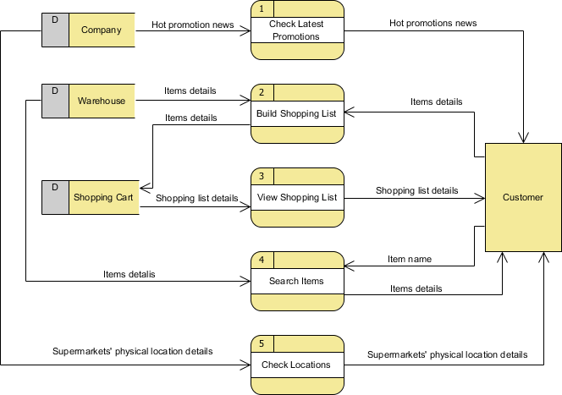

## User Stories

Use the below table to define user stories for this project:

|  |  |  |  |  |  |  |
| --- | --- | --- | --- | --- | --- | --- |
| **Activity** | **User Story (Top Priority)** | **Story (Enhancement)** | **Story (Later Release)** | **Activity** | **User Story (Top Priority)** | **Story (Enhancement)** |
| **Explore Metrics** | As Retail Manager, I want to view sales by placement zone so I can identify top-performing areas | As Data Analyst, I want drill‑down filters by category so I can segment performance | As Marketing Lead, I want trend lines across weeks so I can track seasonality | **Explore Metrics** | As Retail Manager, I want to view sales by placement zone so I can identify top-performing areas | As Data Analyst, I want drill‑down filters by category so I can segment performance |
| **Analyze Zones** | As Visual Merch, I want heatmaps of traffic so I can optimize layout | As Retail Manager, I want to compare front‑ vs. back‑store performance | As Executives, I want to flag low-performing zones and get alerts | **Analyze Zones** | As Visual Merch, I want heatmaps of traffic so I can optimize layout | As Retail Manager, I want to compare front‑ vs. back‑store performance |
| **Compare Placements** | As Marketing Manager, I want to compare placement types (shelf vs endcap) so I can evaluate ROI | As Brand Strategist, I want time‑series comparison of placements | As Data Analyst, I want benchmarking vs. last quarter | **Compare Placements** | As Marketing Manager, I want to compare placement types (shelf vs endcap) so I can evaluate ROI | As Brand Strategist, I want time‑series comparison of placements |
| **Export Insights** | As Brand Strategist, I want exportable dashboard PDFs so I can present findings | As Retail Manager, I want annotated screenshots of charts | As Executive, I want email summary alerts of underperformance | **Export Insights** | As Brand Strategist, I want exportable dashboard PDFs so I can present findings | As Retail Manager, I want annotated screenshots of charts |
| **Take Action** | As Strategy Lead, I want recommendations for placement changes so I can drive layout updates | As Retail Manager, I want to model sales impact for repositioning | As Data Analyst, I want predictive placement modeling | **Take Action** | As Strategy Lead, I want recommendations for placement changes so I can drive layout updates | As Retail Manager, I want to model sales impact for repositioning |
| Manager | Dashboard Sharing | USN-6 | As a manager, I want to download or share the dashboard insights with my team. | Dashboard is shareable via Tableau link or export | Medium | Sprint-4 |

### 3.4 Technology Stack

Tableau Public, Tableau Prep, Microsoft Excel, CSV dataset

**Table-1 : Components & Technologies:**

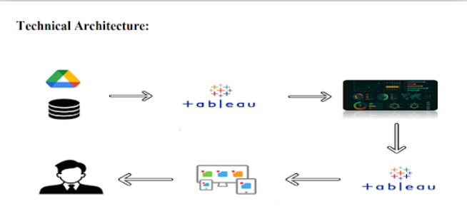

|  |  |  |  |
| --- | --- | --- | --- |
| **S.No** | **Component** | **Description** | **Technology** |
| 1 | User Interface | Final dashboard seen by end users | Tableau Public, HTML, Flask |
| 2 | Data Source | Housing dataset source | Google Drive / Local CSV |
| 3 | Data Collection | Gathering dataset for analysis | Manual / Scripted download |
| 4 | Data Preparation | Cleaning & transformation | Tableau Prep |
| 5 | Data Visualization | Building charts & visuals | Tableau Public Desktop |
| 6 | Dashboard & Story | Visual storytelling with filters | Tableau Story |
| 7 | Web Integration | Embedding dashboards into UI | Flask (Python Web Framework) |
| 8 | Hosting Infrastructure | Hosting the Flask app | Localhost / Web server |

**Table-2: Application Characteristics:**

|  |  |  |
| --- | --- | --- |
| **S.No** | **Characteristics** | **Description & Technology** |
| 1 | Open-Source Frameworks | Tableau Public, Flask |
| 2 | Security Implementations | Dataset access via local storage or private Tableau links |
| 3 | Scalable Architecture | Layered and modular architecture flow |
| 4 | Availability | Accessible via Tableau Cloud and Flask Web App |
| 5 | Performance | Optimized Tableau dashboards using filters and cache |

## 4. PROJECT DESIGN

### 4.1 Problem–Solution Fit

**Problem–Solution Fit**

**The Problem:**

Retail analysts and decision-makers are overwhelmed by large, unstructured sales and placement data across multiple store locations. They struggle to identify how shelf placement, product category, and store zones influence product performance. Manual analysis through spreadsheets is time-consuming, inefficient, and often leads to delayed or unclear merchandising strategies.

**The Solution:**

A Tableau-based interactive dashboard that visually presents key metrics such as total sales, shelf placement impact, and product-wise performance across store locations. Built using Tableau Prep for clean and reliable data, the dashboard transforms complex retail data into intuitive visuals, enabling fast, data-driven merchandising decisions.

**Why It Fits:**

The solution directly addresses the core challenge: transforming raw sales and placement data into clear, actionable insights. It aligns with the workflows of retail analysts and marketing teams, reduces manual effort, improves accuracy, and empowers decision-makers to optimize product placement strategies confidently and efficiently.

**Purpose:**

* To simplify complex retail sales and placement data for non-technical users.
* To reduce manual analysis time and improve operational efficiency.
* To help users quickly identify sales trends and optimize product placement strategies.
* To replace static reports with interactive, shareable visualizations.
* To enable retailers to track, interpret, and respond to product performance across stores in real time.

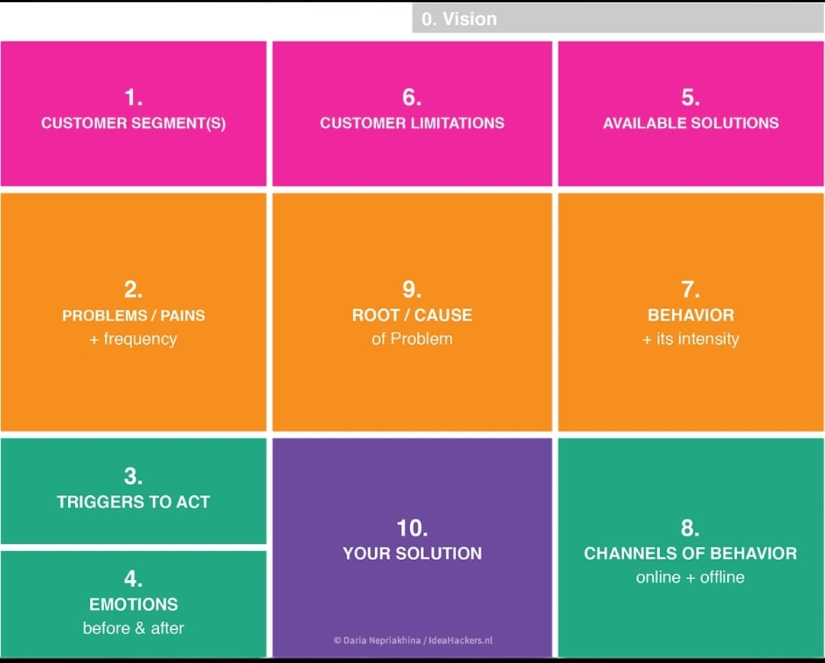

### 4.2 Proposed Solution

|  |  |  |
| --- | --- | --- |
| **S.No.** | **Parameter** | **Description** |
| **1** | **Problem Statement (Problem to be solved)** | Retail analysts and stakeholders face challenges identifying how product placement, shelf position, and category affect sales due to unstructured data and lack of visual tools. |
| **2** | **Idea / Solution Description** | Develop an interactive Tableau dashboard using cleaned retail sales data (via Tableau Prep) that displays KPIs, shelf performance, and category-wise comparisons to support faster, data-driven decisions. |
| **3** | **Novelty / Uniqueness** | This solution integrates data cleaning and visualization seamlessly using Tableau Prep and Tableau Public, replacing static spreadsheets with real-time, interactive insights. |
| **4** | **Social Impact / Customer Satisfaction** | Enhances retail decision-making accuracy, reduces manual effort, improves communication across teams, and ensures stakeholders have immediate access to placement performance insights. |
| 5 | |  |  | | --- | --- | | **Business Model (Revenue Model)** |  | | |  | | --- | | Enables retail companies to optimize product placement and merchandising strategies, leading to higher sales and ROI. The dashboard can also be positioned as a reusable internal analytics tool or scaled as a commercial SaaS product for other retailers. | |
| 6 | |  |  | | --- | --- | | **Scalability of the Solution** |  | | |  |  | | --- | --- | |  | The dashboard is designed to scale across multiple store locations, product categories, and time periods. It supports integration with real-time sales systems and allows easy addition of new filters, visuals, or predictive modules as business needs evolve. | |

### 4.3 Solution Architecture

**Solution Architecture Diagram:**

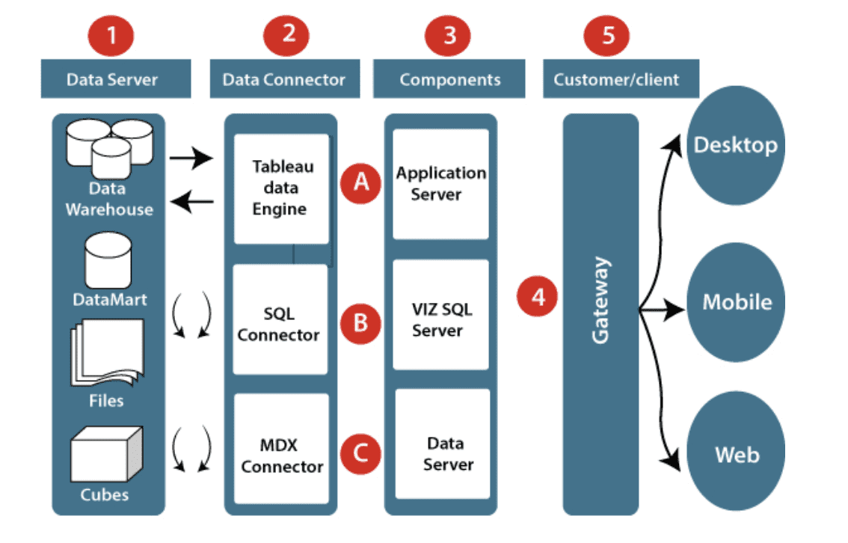

*Architecture and data flow of* Strategic Product Placement Analysis:

Unveiling Sales Impact with Tableau Visualization

5. PROJECT PLANNING & SCHEDULING

### 5.1 Project Planning

## Product Backlog, Sprint Schedule, and Estimation :

|  |  |  |  |  |  |  |
| --- | --- | --- | --- | --- | --- | --- |
| Sprint | Functional Requirement (Epic) | User Story Number | User Story / Task | Story Points | Priority | Team Members |
| Sprint-1 | Data Collection | USN-1 | As a data analyst, I want to download the housing dataset for processing. | 2 | High | Mahankali Komal Naga Venkata Raghu Ram |
| Sprint-1 | Data Collection | USN-2 | As a data analyst, I want to load the dataset into Tableau Prep. | 1 | High | Kosuru  Aravind |
| Sprint-1 | Data Preparation | USN-3 | As a data analyst, I want to handle missing values in the dataset. | 3 | High | Kummari  Maneendra |
| Sprint-1 | Data Preparation | USN-4 | As a data analyst, I want to transform categorical features. | 2 | Medium | Kummari  Maneendra |
| Sprint-2 | KPI Visualization | USN-5 | As a stakeholder, I want to view KPIs like average sale price and record count. | 2 | High | Teja Kondeti |
| Sprint-2 | Visualization by Renovation | USN-6 | As a stakeholder, I want to see how renovations affect house prices. | 2 | Medium | Teja Kondeti |
| Sprint-2 | Feature-based Visualization | USN-7 | As a stakeholder, I want to see house age by bathrooms, bedrooms, and floors. | 3 | High | Mahankali Komal Naga Venkata Raghu Ram |
| Sprint-2 | Dashboard Sharing | USN-8 | As a manager, I want to download/share the dashboard with the team. | 1 | Medium | Kosuru  Aravind |

**Project Tracker, Velocity & Burndown Chart**

|  |  |  |  |  |  |  |
| --- | --- | --- | --- | --- | --- | --- |
| Sprint | Total Story Points | Duration | Sprint Start Date | Sprint End Date | Story Points Completed | Sprint Release Date |
| Sprint-1 | 8 | 5 Days | 20 June 2025 | 24 June 2025 | 8 | 24 June 2025 |
| Sprint-2 | 8 | 5 Days | 25 June 2025 | 29 June 2025 | TBD | TBD |

**Velocity :**

**Velocity = Total Story Points Completed / Number of Sprints**

= 8 / 1 = 8 story points/sprint **(after Sprint-1)**

Once Sprint-2 is complete:

Velocity = (8 + 8) / 2 = 8 story points/sprint **(maintained)**

**Burndown Chart:**

Use tools like Excel or Google Sheets to plot:

X-axis: Days of the sprint

Y-axis: Remaining story points

Show planned vs actual burndown

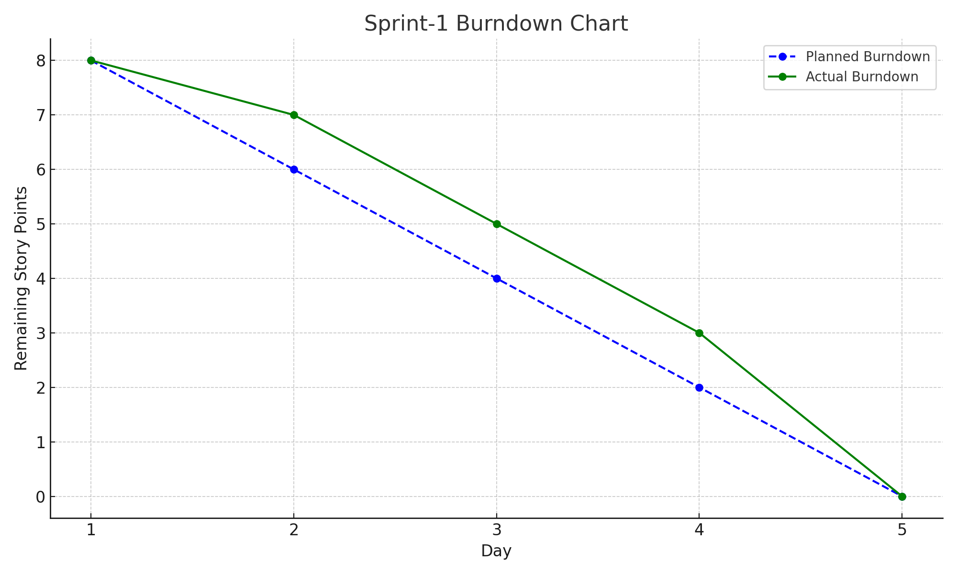

## 6. FUNCTIONAL AND PERFORMANCE TESTING

### 6.1 Performance Testing

## Model Performance Testing:

The project team shall fill the following information in the model performance testing template.

|  |  |  |
| --- | --- | --- |
| **S.No.** | **Parameter** | **Screenshot / Values** |
| **1** | **Data Rendered** | Retail sales and product placement dataset from CSV, cleaned using Tableau Prep, visualized in Tableau Public |
| **2** | **Data Preprocessing** | Null values removed, product categories standardized, shelf zones labeled, aggregated KPIs calculated |
| **3** | **Utilization of Filters** | Filters for Product Category, Shelf Placement, Store Region, Promotion Zone, and Time Period |
| **4** | **Calculation Fields Used** | Total Sales, Average Revenue per Shelf, Placement Effectiveness Score, Count of Products Sold |
| **5** | **Dashboard Design** | KPIs (3), Pie Chart (1), Bar Chart (1) → **Total: 6 Visualizations** |
| **6** | **Story Design** | Interactive story sequence showing placement trends, category comparisons, and location insights → **Total: 3Views** |

## 7. RESULTS

### 7.1 Output Screenshots

Dashboard for Visualizing Housing Markey Trends:

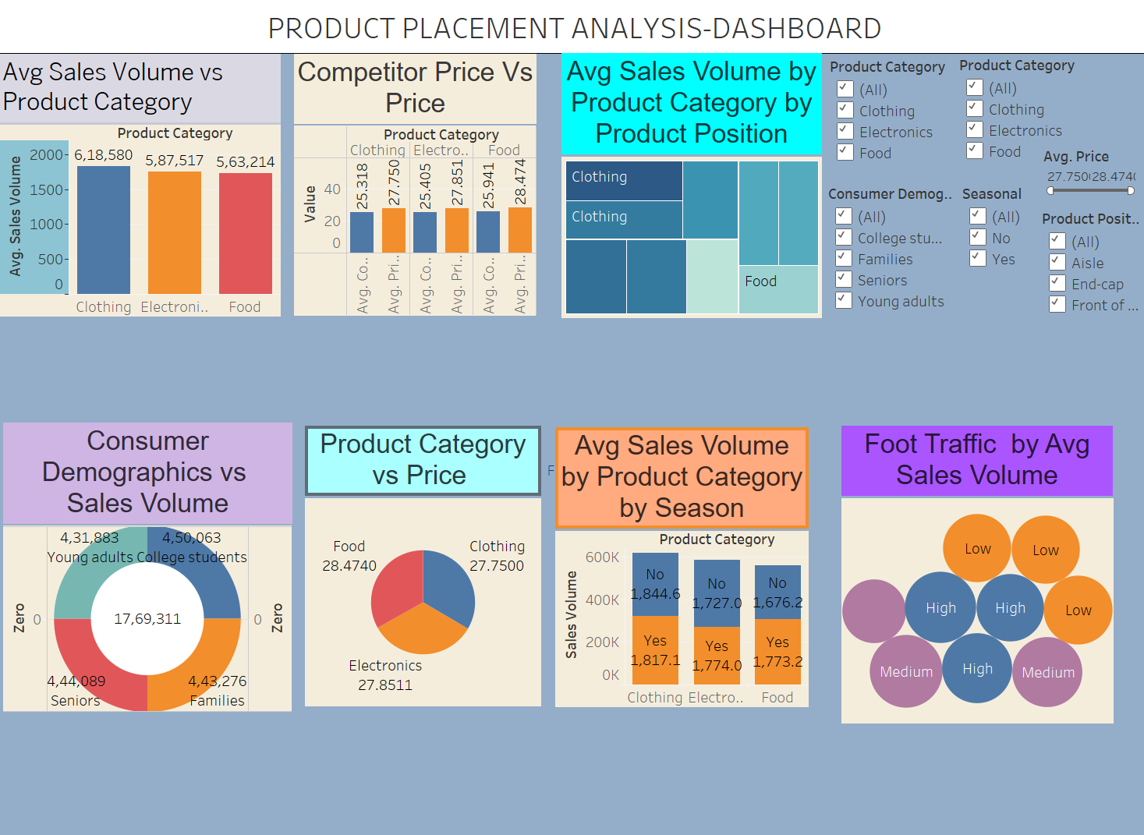

Stories for Visualizing Housing Markey Trends:

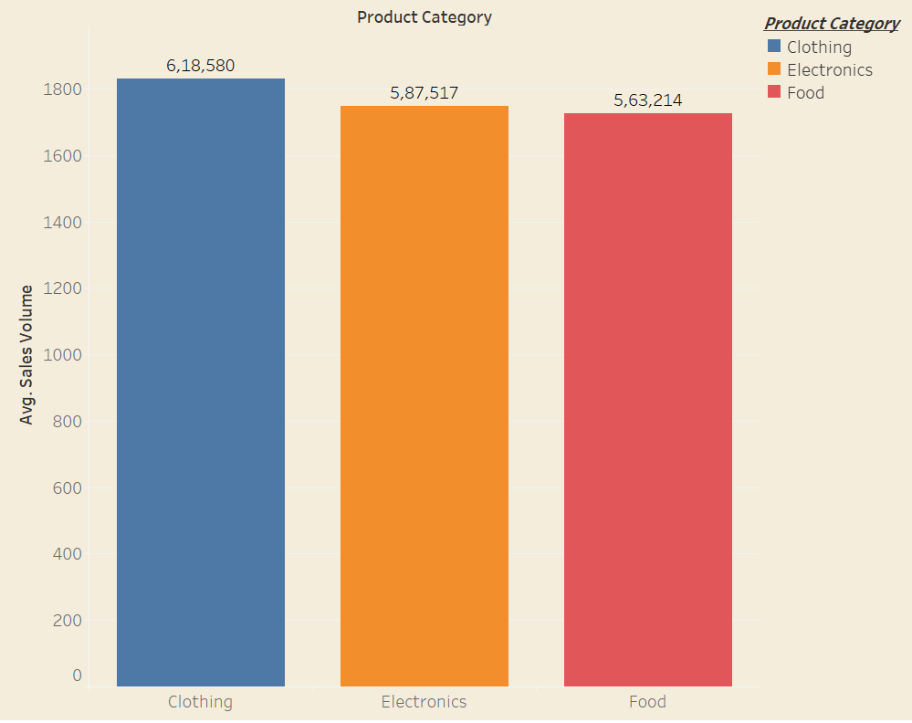

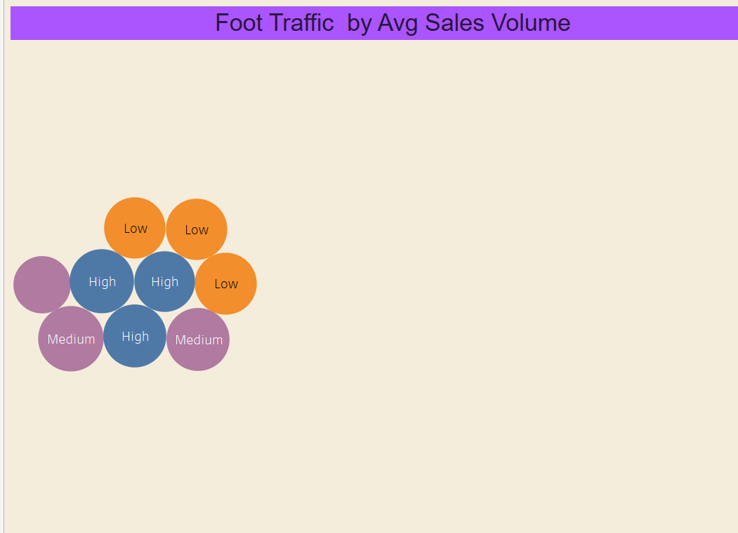

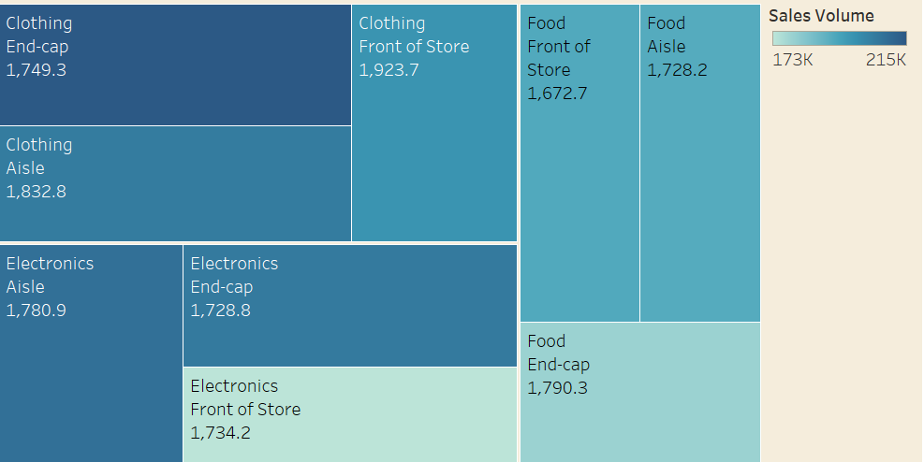

**Links for Dashboard and Stories:**

**for dashboard:**

<https://public.tableau.com/app/profile/kummari.maneendra/viz/StrategicProductPlacementDashboard/Dashboard1?publish=yes>

**for stories:**

<https://public.tableau.com/app/profile/kummari.maneendra/viz/StrategicProductPlacementStory/Story1?publish=yes>

**8. ADVANTAGES & DISADVANTAGES**

**Advantages:**

## Fast insights: Users can quickly understand trends in product sales, placement impact, and category-wise performance.

## Visual clarity: Charts and KPIs make complex sales and merchandising data for clear interpretation.

## Interactive filtering: Stakeholders can filter by product category, shelf zone, store location, and time to explore specific insights.

## Time-saving: Eliminates the need for manual analysis through spreadsheets, improving decision speed.

## User-friendly: Designed for non-technical retail managers and marketers to derive actionable insights easily.

## Disadvantages:

## Limited to visualization: The dashboard focuses on descriptive analytics and does not support predictive modeling or advanced forecasting.

## Tool dependency: The solution relies on Tableau Prep and Tableau Public, which may restrict integration with other enterprise tools or platforms.

## Requires clean data input Inaccurate or unclean sales and placement data can reduce the reliability and usefulness of the visualizations.

## 9. CONCLUSION

The project **“Strategic Product Placement Analysis using Tableau”** effectively demonstrates how data visualization can simplify complex retail sales and placement data to deliver actionable insights. By using Tableau Prep for data cleaning and Tableau Public for building interactive dashboards, the solution enables stakeholders to quickly explore trends in product performance, shelf placement impact, and category-wise sales distribution.

This approach addresses the limitations of manual spreadsheet-based analysis by offering a faster, more intuitive way to understand large volumes of retail data. It supports better decision-making for analysts, marketers, and store managers through interactive KPIs and comparative visualizations presented in a user-friendly format.

Overall, the project improves merchandising strategy, enhances operational efficiency, and lays the groundwork for integrating advanced analytics like forecasting or optimization in the future.

## 10. FUTURE SCOPE

## Incorporate Predictive Analytics: Integrate machine learning models to forecast product sales based on past trends, seasonality, and placement history.

## Expand to Other Retail Chains or Regions: Apply the same dashboard framework to other store locations, cities, or partner retailers for broader performance insights..

## Integrate Real-Time Sales Data: Connect the dashboard with POS systems or API feeds to ensure real-time monitoring and continuous updates.

## Enable User Customization: Allow users to personalize dashboards by selecting specific categories, regions, or KPIs relevant to their roles.

## Develop Mobile-Friendly Dashboards: Optimize the dashboard layout for tablets and mobile devices to enhance accessibility for on-the-go decision-makers.

## 11. APPENDIX

Dataset link:

GitHub & Project Demo Link:

https://github.com/Maneendrakummari/strategic-product-analysis